**Blood and Circulation**

The circulatory system consists of three organs. They are:

* Blood vessels
* Blood
* Heart

Its function is to transport various substances around the body. Some of these are:

Nutrients, wastes, hormones. _______________________________________________________________

**Blood**

The human body has about 5_____ litres of blood. Human blood is made of four components; plasma, red blood cells, white blood cells and platelets.

**Plasma**

Plasma is the main component of blood, consisting mainly of water_______ . It is pale yellow________ in colour. Plasma carries hormones, nutrients, and wastes. Suspended in the plasma are the red________ and white____ blood cells and platelets__________ .

**Red Blood Cells**

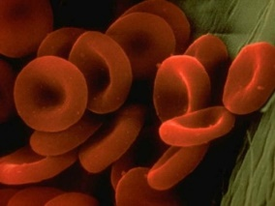Red blood cells carry oxygen_____ throughout the body. Oxygen combines with an iron containing chemical called haemoglobin_________________ in the blood cells. Red blood cells are disc/biconcave shaped and do not have a nucleus___________ .

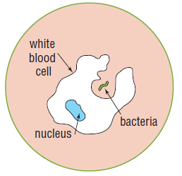**White Blood Cells**

White blood cells are bigger and less numerous than red blood cells. They have no definite shape ___ _________ _______ , but possess a nucleus__________ . White blood cells are mostly involved in fighting disease__________ ____________ . They protect the body from disease by ‘eating’ foreign material_________ ___________ and bacteria__________ in the blood.

**Platelets**

Platelets are tiny cells with no nucleus_________ . They are involved in the clotting of blood____________ ___ _________ . Platelets form sticky clots_______ that plug up damaged blood vessels_________ _____________ .

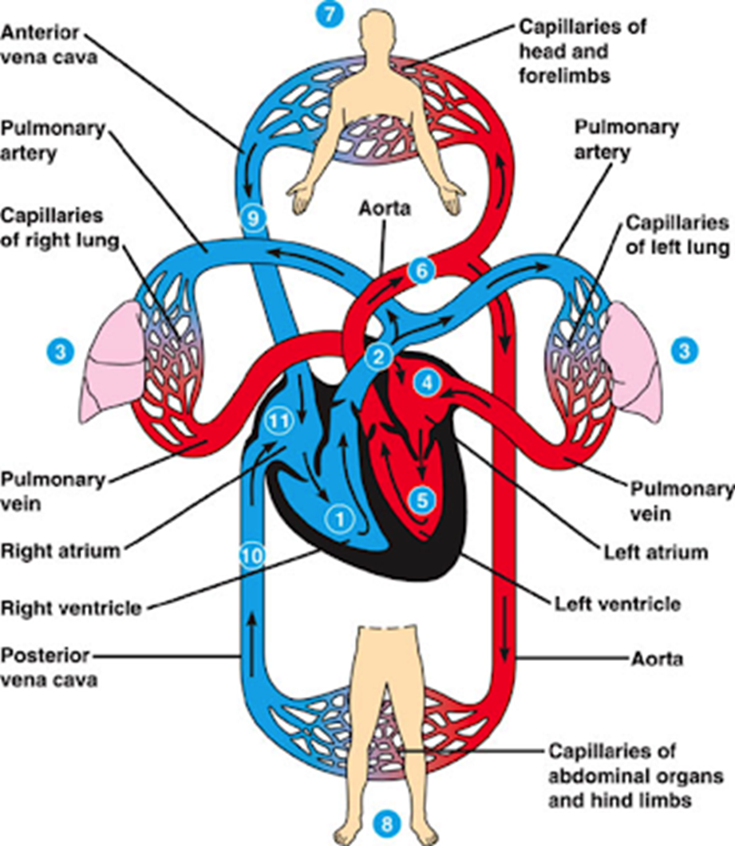

**Circulation**

1. Describe the path blood takes through the body from the right ventricle (1) to the left ventricle (5)

From the right ventricle to the pulmonary artery, to the lungs, to the pulmonary vein, into the left atrium, to reach the left ventricle. __________________________________________________________________________________________________________________________________________

1. Describe the path blood takes from the left ventricle (5), back to the right ventricle (1)

From the left ventricle, to the aorta, through the abdominal organs (or head), to the vena cava, then the right atrium, back to the right ventricle. _____________________________________________________________________________________________________________________________________________________________________________________________________________